EXP1: Simulation of FDMA in MATLAB
Objective 1:
To simulate an FDMA system by allocating individual frequency channels to multiple users
and determine the channel bandwidth assigned to each user.
Program (MATLAB Code)
clc; clear; close all;
fs=1000; t=0:1/fs:1;
TBW=600; Users=3;

CBW=TBW/Users;
fc=[100 300 500];
m=sin(2*pi*10*t);
s1=m.*cos(2*pi*fc(1)*t);
s2=m.*cos(2*pi*fc(2)*t);
s3=m.*cos(2*pi*fc(3)*t);
subplot(2,1,1)
plot(t,s1,'r',t,s2,'g',t,s3,'b'),grid on
title('FDMA Channel Allocation'),xlabel('Time (s)'),ylabel('Amplitude')
subplot(2,1,2)
bar(1:Users,CBW*ones(1,Users)),grid on
xlabel('Users'),ylabel('Channel Bandwidth (kHz)'),title('Channel Bandwidth per User')
OUTPUT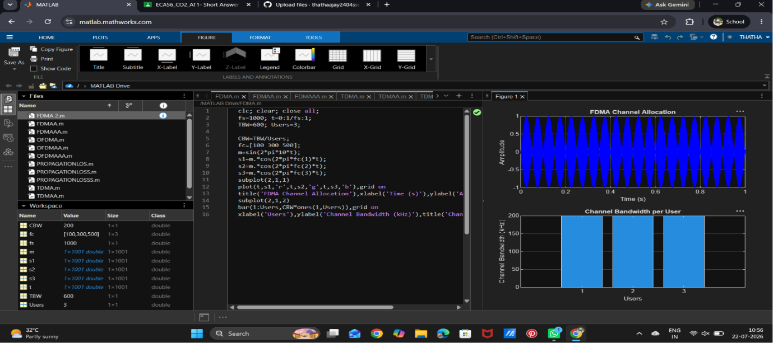
Objective 2:
To calculate the data rate achieved by each user in the FDMA system based on the allocated
channel bandwidth.
Objective 2: Matlab Code
clc; clear; close all;
BW = 200; % Channel Bandwidth (kHz)
Users = 3;
M = 2; % BPSK Modulation
DataRate = BW*log2(M); % Data Rate (kbps)
Rate = DataRate*ones(1,Users);
disp(' User Data Rate (kbps)')
disp([(1:Users)' Rate'])
figure
bar(1:Users,Rate)
xlabel('Users')
ylabel('Data Rate (kbps)')
title('FDMA Data Rate for Each User')
grid on
OUTPUT
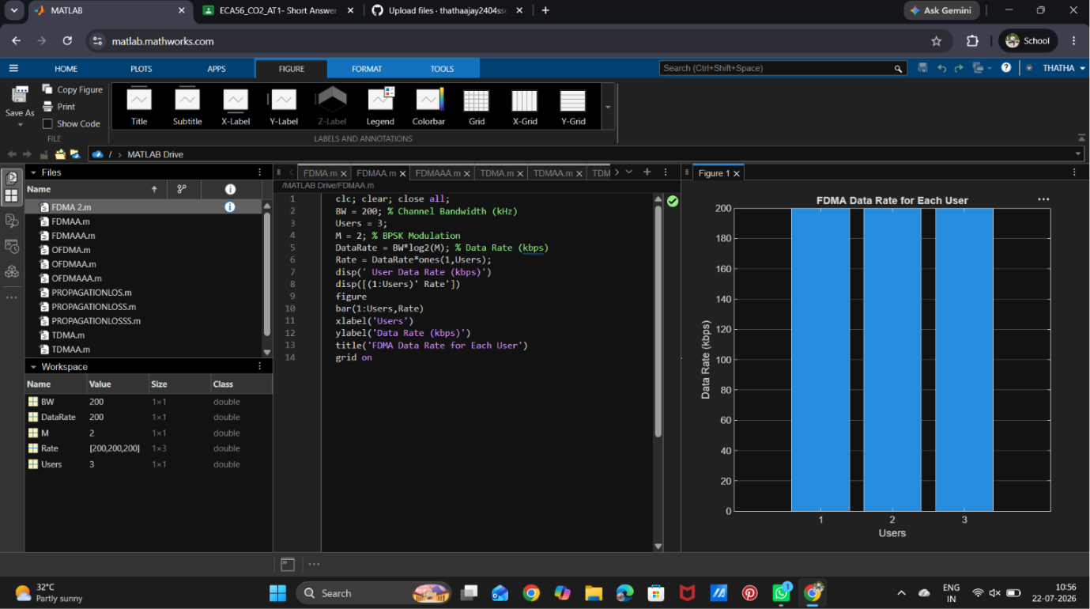

Objective 3:
To evaluate the communication quality of the FDMA system by calculating the Signal-to-
Noise Ratio (SNR) for different users.
Objective 3: Matlab Code
clc; clear; close all;
Ps = 1; % Signal Power (W)
Pn = [0.1 0.05 0.01]; % Noise Power (W)
Users = 1:3;
SNR = 10*log10(Ps./Pn); % SNR in dB
disp('User Noise Power(W) SNR(dB)')
disp([Users' Pn' SNR'])
figure
bar(Users,SNR)
xlabel('Users')
ylabel('SNR (dB)')
title('Signal-to-Noise Ratio of FDMA Users')
grid on
OUTPUT:
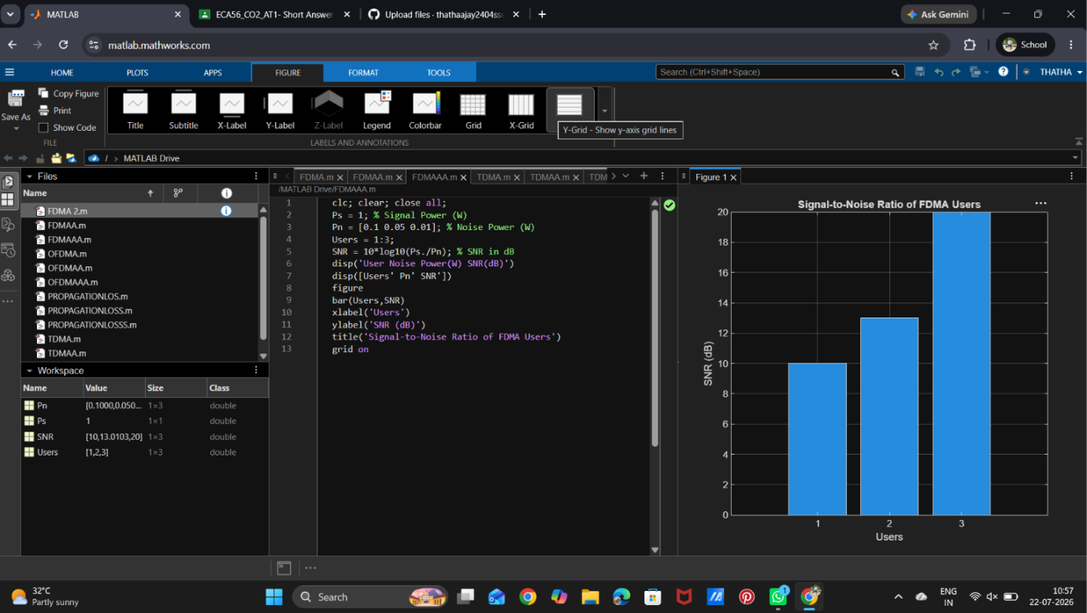
Result:

1. The FDMA system was successfully simulated by allocating separate frequency channels to three users, and the channel bandwidth assigned to each user was determined.
2. The data rate achieved by each user was successfully calculated based on the allocated channel bandwidth, demonstrating equal transmission capacity for all users.
3. The Signal-to-Noise Ratio (SNR) for different users was successfully evaluated, showing that higher SNR values provide better communication quality and reliable data transmission.

